|  |  |  |  |  |
| --- | --- | --- | --- | --- |
| AIUB | **American International University- Bangladesh (AIUB)**  **Faculty of Engineering (FE)**  **Department of Computer Science & Engineering (CSE)** | | | |
|  | |  |  |  | |
| **Course Name:** | | Digital Logic and Circuits Lab | **Course Code:** | EEE 3102 | |
| **Semester:** | | Summer 2022-2023 | **Section:** | F | |
| **Faculty Name:** | | Shahriyar Masud Rizvi | | | |
|  | |  |  |  | |
| **Project Title:** | | Water Level indicator with Alarm system and Automatic off | | | |
| **Project Group #:** | | 02 | | | |
|  | |  |  |  | |

|  |  |
| --- | --- |
| **Name of the Student** | **ID Number** |
| 1. NOKIBUL ARFIN SIAM | 21-44793-1 |
| 1. AHNAF AHMED | 20-42173-1 |
| 1. SAIFUL ISLAM | 20-42585-1 |
| 1. MAHADI HASAN | 19-39711-1 |
| 1. SHEIKH FAHIM FUAD | 21-44721-1 |

**Assessment Materials and Marks Allocation:**

|  |  |  |  |
| --- | --- | --- | --- |
| **COs** | **Assessment Materials** | **POIs** | **Marks** |
| **CO2** | Course Project Report ***(Analyze a combinational/sequential logic circuit through appropriate survey of research literature to provide valid conclusion acknowledging the limitations.)*** | **P.d.2.C4** | **20** |

|  |  |  |  |  |  |  |
| --- | --- | --- | --- | --- | --- | --- |
| **COs** | **Excellent to Proficient**  **[18-20]** | **Good**  **[15-17]** | **Acceptable**  **[10-14]** | **Unacceptable**  **[1-9]** | **No Response**  **[0]** | **Secured Marks** |
| **CO2**  **P.d.2.C4** | The outcome of the project demonstrates a course project using logic ICs, transistors, switches, display devices, etc. that can solve a complex engineering problem in the electrical and electronic engineering discipline through appropriate research. | The outcome of the project somewhat demonstrates a course project using logic ICs, transistors, switches, display devices, etc., and also somewhat solves a complex engineering problem in the electrical and electronic engineering discipline through some research. | The outcome of the project demonstrates a course project using logic ICs, transistors, switches, display devices, etc. but cannot solve a complex engineering problem properly in the electrical and electronic engineering discipline through appropriate research. | The outcome of the project does not demonstrate a course project using logic ICs, transistors, switches, display devices, etc. also could not solve a complex engineering problem in the electrical and electronic engineering discipline through appropriate research. | No Response at all |  |
| **Comments** |  |  |  |  | **Total Marks (20)** |  |

**Title:**

Water Level indicator with Alarm system and Automatic off

**Abstract:**

The "Water Level Indicator with Alarm System and Automatic Off" project presents a comprehensive and low-cost solution for effective water resource management. With water scarcity becoming a growing concern, monitoring and optimizing water usage are paramount. This project addresses the challenge by incorporating innovative technology to create an automated system that ensures both efficient water utilization and prevention of potential hazards. The core components of this project water level sensor, an alarm system, and a relay for automatic pump control. The water level sensor accurately measures the water level in a tank or reservoir. When the water level reaches the top of the tank, the alarm system is triggered, notifying users of the impending risk of overflow. Moreover, the integration of a relay mechanism enables the automatic shutdown of the water pump when the water level attains a preset limit. This feature not only prevents water wastage but also safeguards against potential flooding and damage. This project serves as an excellent illustration of the integration of sensor technologies, automation, and safety precautions to handle water management difficulties and promote sustainable practices in various home and industrial applications.

**Keywords:** *Water Level Indicator, Alarm System, Automatic Off, relay mechanism, water level sensor, tank.*

**Introduction:**

Water is a most important resource for human life. A human cannot live without water. But now a days water wastage level has become severe. Most of the building water tanks are not have any kinds of alarm indicator that can indicate the water overflow. For this reason, water tanks usually overflow. To eradicate this, matter a Water Level indicator with Alarm system and Automatic off **is** very effective.

To resolve this issue, Water Level indicator with Alarm system and Automatic offneeded to designed and implemented. The system is made of transistor, sensor wire and Relay for automatic off the water pump it can detect four levels of water.

This project’s **objective** is to provide an economical and reliable solution to the water wastage problem. To implement the designed system on a water tank and valid the functionalities properly.To provide a cost-effective, simple and reliable system.The system very user friendly, easy to install and can be integrated into any water tank. By detecting the water level, it could alarm and automatic off and save water.

In this project, we will discuss the design and implementation of the water level indicator. Simulations and experimental test will be conducted to evaluate the system’s performance and robustness. Also, the cost of the components that is used will be monitored and it will be compared to the cost of same kinds of other available systems. The limitations of the system will be addressed to provide a better understanding of the project.

**Literature Review:**

A water level indicator with alarm system and automatic off is a device that can be used to monitor the water level in a tank or reservoir. The device typically consists of a sensor that detects the water level, an alarm system that sounds when the water level reaches a certain level, and a controller that turns off the pump when the water level reaches a certain level.

* “Automatic Water Level Indicator" by Debasis Roy (2018)”. This paper presents a design of an automatic water level indicator using an ultrasonic sensor and a microcontroller. The system can be used to monitor the water level in a tank and send an alarm signal when the water level reaches a critical level. [1]
* “A Review of an Automatic Water Level Indicator" by M.A Barballe et al. (2022)”. This paper reviews the automatic water level indicators. The paper discusses the different types of sensors that can be used, the different alarm systems that can be used, and the different control strategies that can be used. [2]
* “A Microcontroller-Based Water Level Indicator using Radio Frequency RF Technology and Ultrasonic Sensor" by Ifeanyi-Chinaeke Ogbuka (2021)”. This paper presents a design of a microcontroller-based water level indicator that uses radio frequency (RF) technology to transmit the water level data to a remote location. The system can be used to monitor the water level in a tank from a remote location. [3]
* “Design and Implementation of an Automatic Audible Water Level Controller Incorporating a Digital Display” (2019) by S. Arulsamy and S. Palanisamy. This study describes the design and implementation of an automatic water level controller with an audible alarm system and a digital display. The controller uses a float switch to detect the water level in a tank. When the water level reaches a critical level, the alarm system is activated and the digital display shows the current water level. [4]
* “Automatic Water Level Indicator and Controller” by Anikka Pandey (2022). This paper present to help judge the water position inside the water tank and display it consequently on the screen while also precluding any overflow of water which is achieved through the Arduino Uno. The ultrasonic detectors used helps determine the water position in tank which is also shoot to the Arduino Uno, the TV also attached to it displays the position to us. According to the position of water inside the tank, the Arduino helps turn ON or OFF the servo motor hence closing the source of water. In this way, through the robotization of water control, we intent to save the energy and our natural resource.[5]

**Methodology:**

Water Level indicator with Alarm system and Automatic off works on the principle of detecting the water level in a tank. The system comprises of transistor and relay. Attach water level sensors at different levels in the water tank. Connect the sensors to the base of the BC547 transistors through appropriate resistors and connect LEDs to the emitter of the transistor. As the water level changes, the conductivity between LEDs will change at five levels of Empty, Medium, Full and Overflow in the in the tank. When the water level reaches the levels and the buzzer will be alarming. We also Connect the mini water pump to a relay. The relay should be controlled by another transistor based on the desired water level. When the water level rises, the transistor deactivates the relay, allowing the pump to operate.

The wires are connected to the base of transistor which is used to detect the water at each level. When the Water has no water then the LED stays OFF and this state is called Empty then turn on the motor. When the Water container has water at the Low Level the Low-Level Indicator State the LEDs turns ON, the water rises the Full level of the Container then the Full Level State Indicator LED turns ON and when the water rises above the highest level of the Container then the Overflow Level- the circuit turns ON and the alarm sounds and automatic shutdown pump.

**Apparatus:**

|  |  |  |
| --- | --- | --- |
| 1. BC547 NPN Transistor [6 pc] 2. Resistor-1kohm [5 pc] 3. Battery 9V [2 pc] 4. Buzzer [1 pc] | 1. 5V Relay [1 pc] 2. Switch [2 pc] 3. Breadboard 4. Connecting ware 5. Diode 1N4007 [1 pc] | 1. LED--- Red (2pc), yellow(1pc), green(1pc) 2. Water Pump and pipe |

**Experimental setup:**

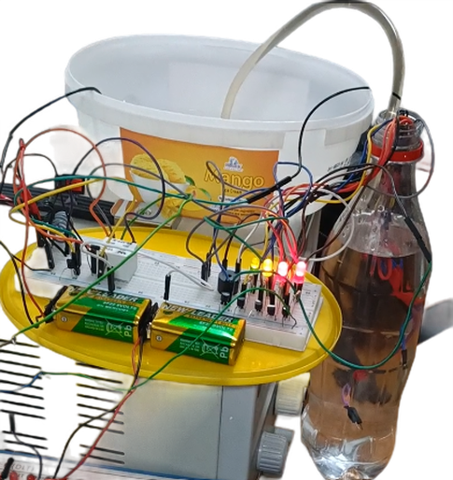

**Simulation:**

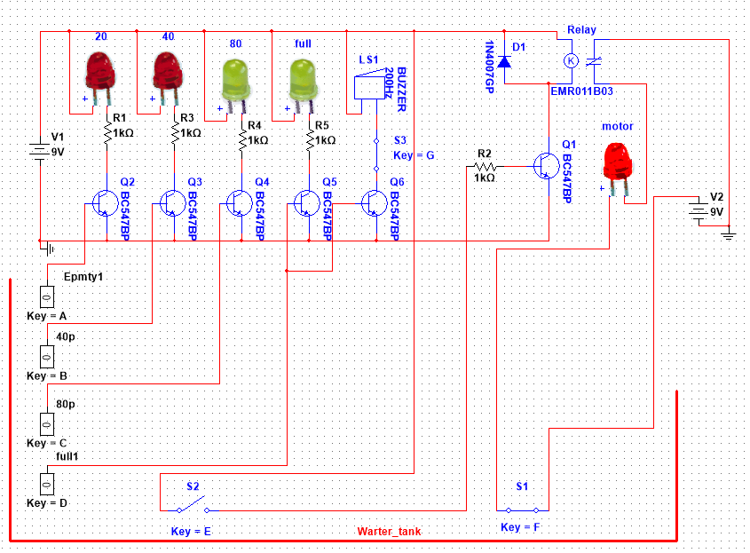

**Results and Discussion:**

The system was built and worked well, showing it was dependable and effective. To make sure it would work, tests were done on a board and in a multisim simulation. The results were good, proving the system worked. The simulation on the multisim also worked almost as expected. But when the team tried to make the real thing, they face some problems. They solved these problems quickly. Overall, it took a moderate amount of time to make the project, and the project cost 400 – 500 Taka it didn't cost much to make, so it's a good choice for many customers.

**Limitations in the Project:**

Water Level indicator with Alarm system and Automatic off had proven to be effective in resolving water wastage problem but there were some limitations in this system.

The system isn't completely automatic, so the user has to start it by hand, which is a big disadvantage. Another problem is that some parts of the system might need to be replaced after a while, which adds maintenance costs. The system can get rusty and needs good care. Lastly, it doesn't have an official certification, so there's no assurance that it will work perfectly.

**Conclusion and Future Endeavors:**

The Water Level Indicator project equipped with an Alarm System and an Automatic Off feature has successfully demonstrated its practicality and utility in managing water levels effectively. By using a relay for the automatic shutdown of the water pump, this system ensures optimal water usage, prevents overflow, and mitigates wastage. The integration of an alarm system adds an extra layer of alertness, promptly notifying users about critical water levels and potential issues. This project holds great significance, particularly in contexts where water conservation and resource management are crucial. Its user-friendly design and automation capabilities enhance convenience while promoting responsible water usage. As such, the Water Level Indicator with Alarm System and Automatic Off stands as an exemplary innovation that addresses water-related challenges, making a positive contribution to sustainability and efficient resource utilization.

Here are some future endeavors,

* **IoT Integration:** Explore integrating the system with Internet of Things (IoT) platforms for real-time monitoring and control from anywhere via smartphone apps or web interfaces.
* **Rainwater Harvesting Integration:** Extend the project to work in tandem with rainwater harvesting systems, optimizing the use of available water sources and enhancing overall sustainability.
* **Voice Command Activation:** Implement voice recognition technology to enable users to control and monitor the water level system using voice commands, adding a layer of convenience.
* **Water Quality Monitoring:** Including sensors to monitor water quality parameters would provide a more comprehensive solution, alerting users to potential contamination issues.

**Reference:**

[1] R. Debasis "Automatic Water Level Indicator." International Journal of Recent Technology and Engineering (IJRTE), vol. 8, no. 2, 2019, 2019.

[2] M.A Barballe, A.S Muhammad "A Review of an Automatic Water Level Indicator," Global Journal of Research in Engineering, vol. 13, no. 2, 2022.

[3] C. Ogbuka, "A microcontroller-based water level indicator using radio frequency (RF) technology and ultrasonic sensor," Sensors, vol. 19, no. 18, 2019.

[4] S. Arulsamy and S. Palanisamy, "Design and Implementation of an Automatic Audible Water Level Controller Incorporating a Digital Display," International Journal of Innovative Studies in Sciences and Engineering Technology, vol. 6, no. 4, 2019.

[5] A. Pandey, G. Andhale, A. Sonawane, A. Amrutkar and T. Andhare, “Automatic Water Level Indicator and Controller,” International Journal for Research in Applied Science & Engineering Technology (IJRASET), vol. 10, no. 2, 2019.